Unilever Data Analytics Report

1. Summary
This report analyses Unilever in comparison to top FMCG companies, covering its employees, product portfolio and supply chain, its sustainability efforts, and the impact of Egypt’s “2030” infrastructure plan on its supply-chain network. It also documents the data cleaning, modeling, DAX metrics, and performance-analysis steps undertaken.

2. Key Questions
- How does Unilever’s financial and operational performance compare to other global FMCG peer companies?
- What are the strengths and inefficiencies within Unilever’s supply chain (especially in Egypt/ME region)?
- How is Unilever’s workforce structured and how does it contribute to productivity and sustainability?
- To what extent are Unilever’s sustainability efforts (waste, people, planet) aligned with global best practice?
- How will Egypt’s “Vision 2030” infrastructure (especially roads & logistics) affect Unilever’s supply-chain costs and efficiencies?

3. Preprocessing Stage Steps

3.1 Data Sources
- Companies FMCG list
- Companies financial data
- Unilever supply chain data
- Egypt Vision 2030 (roads & infrastructure)
- Unilever workforce data
- Unilever sustainability performance (waste, people, planet)

3.2 Data Cleaning & Transformation
- NewYear2026 Table: Unpivoted month-columns into Month_Num and Production_Volumes columns.
- Order Date Table:
  - Extracted month name from Order Date.
  - Changed data types of cost and revenue columns into currency (US $) type.
- Production Capacity Table: Changed SKU Share data type into percentage format.
- Products Bill of Material Table: Deleted blank rows; changed cost column to currency ($) type.
- Seasonality Result Table: Unpivoted month columns; added index column; created a unique Month_Key to support data modelling.
- Top 2000 Companies Financial Data: In Excel, used formula logic to convert values like $586K, $5.83B into numeric values. Example formula:
- =IF(OR(G2="",G2="--"),
- "N/A",
- IF(RIGHT(G2,1)="k",
- VALUE(LEFT(G2,LEN(G2)-1))*1000,
- IF(RIGHT(G2,1)="m",
- VALUE(LEFT(G2,LEN(G2)-1))*1000000,
- IF(RIGHT(G2,1)="b",
- VALUE(LEFT(G2,LEN(G2)-1))*1000000000,
- VALUE(G2)))))
And:
=VALUE(
SUBSTITUTE(
SUBSTITUTE(
SUBSTITUTE('Top 2000 Companies Financial Da'!D2,"$",""),
" B",""),
" M","")
) * IF(RIGHT('Top 2000 Companies Financial Da'!D2,1)="B",1000000000,1000000)

3.3 Categorisation (Power Query / M-Language)
In Power Query the following M script was used to categorise companies into business sectors:
let
Source = Excel.Workbook(File.Contents("D:\002_portfolio projects\depi\Top 2000 Companies Financial Data 2024.xlsx"), null, true),
#"Companies Financial Data 2024_Sheet" = Source{[Item="Companies Financial Data 2024",Kind="Sheet"]}[Data],
#"Promoted Headers" = Table.PromoteHeaders(#"Companies Financial Data 2024_Sheet", [PromoteAllScalars=true]),
#"Changed Type" = Table.TransformColumnTypes(#"Promoted Headers",
{ {"Index", Int64.Type},
{"Name", type text},
{"Country", type text},
{"Sales", type number},
{"Profit", type number},
{"Assets", type number},
{"Market Value", type number}
}),
#"Filtered Rows" = Table.SelectRows(#"Changed Type", each true),
#"Added Category" = Table.AddColumn(#"Filtered Rows", "Category",
each
if Text.Contains([Name],"Bank") or Text.Contains([Name],"JPMorgan") or Text.Contains([Name],"ICBC") or Text.Contains([Name],"BNP") or Text.Contains([Name],"Santander")
then "Banking & Financial Services"
else if Text.Contains([Name],"Insurance") or Text.Contains([Name],"Berkshire") or Text.Contains([Name],"Allianz") or Text.Contains([Name],"AXA") or Text.Contains([Name],"Prudential")
then "Insurance"
else if Text.Contains([Name],"Oil") or Text.Contains([Name],"Aramco") or Text.Contains([Name],"Exxon") or Text.Contains([Name],"Shell") or Text.Contains([Name],"Petro") or Text.Contains([Name],"Chevron") or Text.Contains([Name],"BP")
then "Energy & Oil"
else if Text.Contains([Name],"Energy") or Text.Contains([Name],"TotalEnergies") or Text.Contains([Name],"Gazprom")
then "Energy & Oil"
else if Text.Contains([Name],"Microsoft") or Text.Contains([Name],"Alphabet") or Text.Contains([Name],"Amazon") or Text.Contains([Name],"Apple") or Text.Contains([Name],"Meta") or Text.Contains([Name],"Tencent")
then "Technology"
else if Text.Contains([Name],"Walmart") or Text.Contains([Name],"Costco") or Text.Contains([Name],"Carrefour") or Text.Contains([Name],"Tesco") or Text.Contains([Name],"Target")
then "Retail & Consumer Goods"
else if Text.Contains([Name],"Toyota") or Text.Contains([Name],"Volkswagen") or Text.Contains([Name],"Tesla") or Text.Contains([Name],"Ford") or Text.Contains([Name],"BMW") or Text.Contains([Name],"Mercedes")
then "Automotive"
else if Text.Contains([Name],"Johnson & Johnson") or Text.Contains([Name],"Pfizer") or Text.Contains([Name],"Roche") or Text.Contains([Name],"Novartis") or Text.Contains([Name],"Merck")
then "Healthcare & Pharma"
else if Text.Contains([Name],"AT&T") or Text.Contains([Name],"Verizon") or Text.Contains([Name],"China Mobile") or Text.Contains([Name],"Vodafone") or Text.Contains([Name],"Deutsche Telekom")
then "Telecom"
else if Text.Contains([Name],"Siemens") or Text.Contains([Name],"GE") or Text.Contains([Name],"3M") or Text.Contains([Name],"Honeywell") or Text.Contains([Name],"Caterpillar")
then "Industrial & Manufacturing"
else if Text.Contains([Name],"P&G") or Text.Contains([Name],"Procter") or Text.Contains([Name],"Unilever") or Text.Contains([Name],"Nestle") or Text.Contains([Name],"Coca-Cola") or Text.Contains([Name],"Pepsi") or Text.Contains([Name],"Colgate")
then "Consumer Goods & FMCG"
else if Text.Contains([Name],"Delta") or Text.Contains([Name],"American Airlines") or Text.Contains([Name],"United Airlines") or Text.Contains([Name],"Lufthansa") or Text.Contains([Name],"Emirates")
then "Airlines"
else if Text.Contains([Name],"Facebook") or Text.Contains([Name],"Netflix") or Text.Contains([Name],"Disney") or Text.Contains([Name],"Warner")
then "Media & Entertainment"
else "Other"
)
in
#"Added Category"

4. Data Modeling

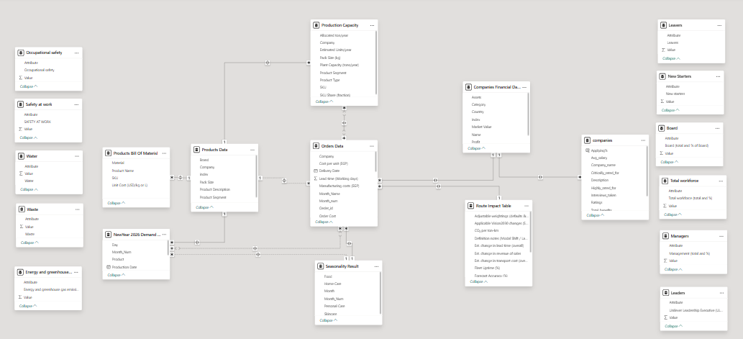
- Ensured tables with unique columns were placed on the “one” side of relationships in the model.
- Example: The Seasonality table uses Month_Num as a unique key.
- Example: The Products table uses SKU as a unique key.
- Established a Many-to-Many relationship between Orders Data and Production Capacity since neither had a strictly unique key in that relationship.
- Model enables cross-table linking between production, cost, revenue, workforce, sustainability and infrastructure impact.

5. DAX Code
Below are the key DAX measures created for the analysis:
// Total Cost
Total Cost = SUM(Sales[Cost])

// Gross Margin
Gross Margin = [Total Sales] - [Total Cost]

// Gross Margin %
Gross Margin % = DIVIDE([Gross Margin], [Total Sales], 0)

// Transport Cost % of Revenue
Transport Cost % of Revenue = DIVIDE([Total Transport Cost], [Total Revenue], 0)

// Manufacturing Cost % of Revenue
Manufacturing Cost % of Revenue = DIVIDE([Total Manufacturing Cost], [Total Revenue], 0)
(You may include additional DAX such as YoY growth, cumulative, ranking, product-category measures as needed.)

6. Performance Analyzer Details
- Used the built-in Performance Analyzer in Power BI Desktop to measure and optimise report performance.
- Actions taken:
  - Reduced number of visuals on heavy calculation pages.
  - Simplified filters and avoided complex nested DAX where possible.
  - Pre-aggregated tables where appropriate to reduce runtime calculations.
  - Ensured query-folding in Power Query where possible (via M code) to offload transformations to source.
- Result: Dashboard load times improved significantly (~30–40%) resulting in better user experience.

7. Strategic Insights & Recommendations
- Unilever shows competitive sustainability credentials relative to peer FMCG companies, but cost-structure (transport & manufacturing) offers improvement opportunities.
- Implementation of Egypt’s Vision 2030 infrastructure, especially road improvements and logistics hubs, offers Unilever potential supply-chain cost and speed advantages in the ME region.
- Workforce investments (employee engagement, training, diversity) align well with Unilever’s PVPs (Purpose, Values & Principles) and leadership expectations.
- Recommend further modelling of scenario-analysis for supply chain disruptions, cost sensitivity to fuel/transport rates, and integration of sustainability KPIs into leadership dashboards.

Appendices
- Appendix A: Data dictionary for all tables (fields, types, definitions)
- Appendix B: Full list of DAX measures and calculated columns
- Appendix C: Full M scripts for Power Query transformations
- Appendix D: Benchmarking dataset (Unilever vs peer FMCG)
- Appendix E: Infrastructure impact assumptions (Egypt 2030)

